(Approx. 1677 words)

Digital Camera Anatomy
By Dick Maybach, Member, Brookdale Computer Users Group, NJ
April 2018 issue, BCUG Bytes
www.bcug.com
n2nd (at) att.net

This is the first of three articles on digital cameras covering their anatomy, how their processors control them, and how they process the captured images. An early Kodak slogan was, “You press the button; we do the rest.” Today, modern digital cameras can make the same claim. Most of us have pressed the button; let’s look at the rest of the process.

The First Digital Camera
In 1975, Steven Sasson at Eastman Kodak developed the first digital camera, shown in Figure 1. He used off-the-shelf parts: a movie-camera lens, a newly-developed sensor from Bell Labs, a cassette tape for storage, and a TV monitor to display the images. The camera had a 1/20 second shutter speed but needed 23 seconds to transfer a 100 by 100-pixel black-and-white image to tape. Kodak wasn't interested, because they feared digital cameras would reduce their profits from photographic films. They were right, and in 2012, they filed for bankruptcy.

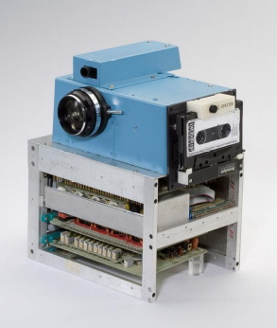
Figure 1. The First Digital Camera.

Camera Types
Figure 1 shows a simplified view of a consumer digital camera architecture; the lens focuses the incoming light onto the photo sensor, which takes the same roll as photographic film. In all but the simplest cameras, a diaphragm with a variable area limits the amount of light entering the camera. (Notable exceptions are cell-phone cameras.) The shutter opens only when you wish to take a picture. Located as shown, it’s called a focal-plane shutter, because it’s very near the plane where the lens focuses the light. The shutter can also be near the lens or it can be integrated into the sensor (which is the case for cell-phone cameras). There are thus two ways to control the amount of light striking the sensor, with the diaphragm and with shutter. Although only a simple lens is shown here, more complex ones are common.

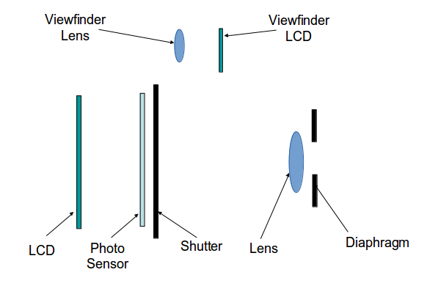
Figure 2. Basic Camera Components.

The liquid crystal display (LCD) shows you where the camera is pointed and lets you look at the pictures you have taken. It also displays the camera status and set-up menus. On higher-end cameras, a second LCD that shows the same information as the one on the rear panel allows for viewing in bright sunlight. The result is called a viewfinder. In older camera the viewfinder was purely optical, with its own lens, but this is rare now. The sensor must operate all the time, whether to provide an image for composing or one for storage, although its resolution is usually reduced for composing. You may have noticed a problem; when the shutter is closed, light can’t strike the photo sensor, and the LCD has nothing to display. Cameras with mechanical shutters hold them open to allow a display, close them briefly when you press the button to allow the photo sensor to be reset for picture taking, and open them for the exposure, and perhaps close them while the image is transferred from the sensor.

A digital single lens reflex (DSLR), shown in Figure 3, places a mirror in the light path to reflect the light into the optical viewfinder whenever the camera is not taking a picture. To take a picture, both mirrors momentarily flip up. Normally, DSLRs also have focal plane shutters since they must be located out of the way of the mirror. Their high-performance sensors often have both mechanical and electronic shutters.

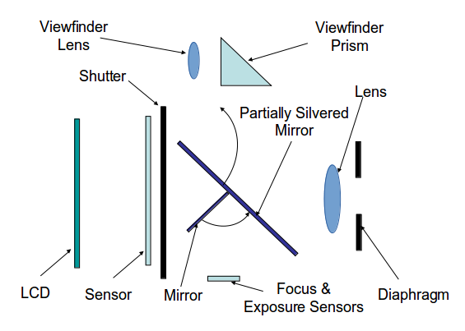
Figure 3. Digital Single Lens Reflex Architecture.

Because the sensor receives light only when taking a picture, the LCD can display only the pictures already taken. Live viewing requires an auxiliary sensor, often located in the viewfinder, as both the shutter and mirror block light from the main sensor. The main mirror is partially silvered to allow some light to pass through it and be reflected down to the focus and exposure sensors by the second mirror. These sensors are optimized for their particular uses since they aren’t used to capture images. This arrangement implies a high price. Besides its mechanical and optical complexity, its lens must be far away from the sensor to clear the mirror. Its main advantages are high-quality pictures and fast operation. Because of its cost, SLR architecture is used only for high-end, interchangeable-lens cameras.

Lenses
The complexity of Figure 4 is typical of modern lenses, although cell-phone and Webcam lenses often have only a single element. Point-and-shoot lens complexity lies between these extremes. The added lens elements correct distortion keeps the light intensity constant across the sensor and reduce color aberration.

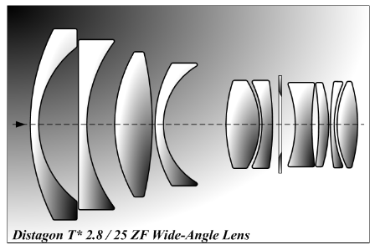
Figure 4. High-end lens.

Digital Sensors
We will now shift gears to look at how the camera records an image. You may be surprised to learn that its sensor does not use the red-green-blue (RGB) format. A computer in the camera changes the recorded information into the desired output format.

Bayer Color Filter Array
Each pixel on a digital camera sensor contains a light sensitive photo diode which measures the brightness of light. Photo-diodes are monochrome devices, unable to sense color. Therefore, a mosaic pattern of color filters is positioned on top of the sensor to allow only red, green, or blue light to illuminate a single pixel. The most common filter used in digital cameras is the GRGB Bayer Pattern, named after a Kodak engineer. The result is a color filter array, shown in Figure 5. By breaking up the sensor into red, blue and green pixels, it is possible to get enough information in the general vicinity of each sensor to make an accurate estimate of the true color there. By contrast, our eyes contain two types of sensors: rods, which are much more numerous, detect only intensity and are most sensitive to green light, and cones, which detect color.

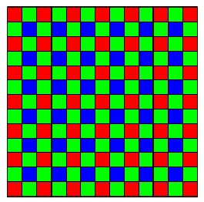
Figure 5. Bayer Filter.

In the Bayer filter pattern, the colors are not evenly divided – there are as many green pixels as there are blue and red combined, because our eyes are more sensitive to green detail than the other colors. The advantages of this method are that only one sensor is required, and all the color information (red, green and blue) is recorded at the same moment. The raw output from a sensor with a Bayer filter is a mosaic of red, green and blue pixels of different intensities. After a raw image has been obtained from a photo-sensor blanketed by a Bayer pattern of color filters, it must be converted into standard red, green, and blue format, usually sRGB or Adobe RGB. A computer in the digital camera determines the correct color for each pixel in the array by averaging the color values of neighboring pixels. This process is called demosaicing.

CMOS Sensor
The Complementary Metal Oxide Semiconductor (CMOS) sensor, shown in Figure 6, is now the dominant type. This sketch shows one CMOS sensor pixel containing a photosensitive area (photo-diode), busses, microlens, Bayer filter, and three support transistors. Each pixel in a CMOS image sensor contains an amplifier transistor, which converts the charge generated by the photo-diode into a voltage. In addition, the pixel also features a reset transistor to control photon accumulation time, and a row-select transistor that connects the pixel output for readout. All this circuitry reduces the photo-diode area. In operation, the first step is to use the reset transistor to drain the charge from the photosensitive region. Next, the integration period begins, and light interacts with the photo-diode region of the pixel to produce electrons, which are stored in the silicon potential well lying beneath the surface.

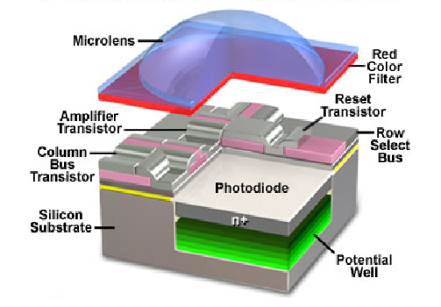
Figure 6. CMOS PixelCell Anatomy.

After the integration period has finished, the row-select transistor is switched on, connecting the amplifier transistor in the selected pixel to its load, thus converting the electron charge in the photo-diode into a voltage. The resulting voltage appears on the column bus and can be detected by the sense amplifier. This cycle is then repeated to read out every row in the sensor in order to produce an image. Keep in mind that even simple cell-phone cameras have millions of these cells on their sensors.

Figure 7 shows a complete CMOS image sensor that contains an active image area of 640 x 480 pixels. The photo-diode array, located in the large reddish-brown central area of the chip, is covered by a Bayer color filter array and a micro-lens array. The inset reveals a highly magnified view of the filter and micro-lens array. Also included on the sensor is the analog signal-processing circuitry to collect and interpret the signals. These then go to the analog-to-digital conversion circuits, located adjacent to the photo-diode array on the upper portion of the chip. You can see the peripheral circuitry located on the edges of the chip.

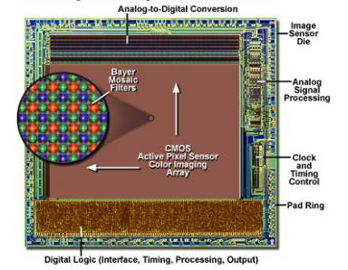
Figure 7. CMOS Image Sensor Integrated Circuit Architecture.

CMOS Functions
In addition to converting photons to electrons and transferring them, the CMOS sensor might also perform image processing, noise reduction, and analog to digital conversion. This functional integration onto a single chip reduces the number of external components needed. Using such an integrated CMOS sensor allows the digital camera to devote less space to other chips, such as digital signal processors (DSPs) and ADCs. CMOS is the dominant semiconductor technology, so these devices enjoy huge economies of scale.

To read out the array, a row is selected, which connects one pixel in each column to the column bus. Each column is then selected in turn, which sends the pixels one at a time to the output amplifier. Figure 8 shows the circuit blocks to accomplish these functions.

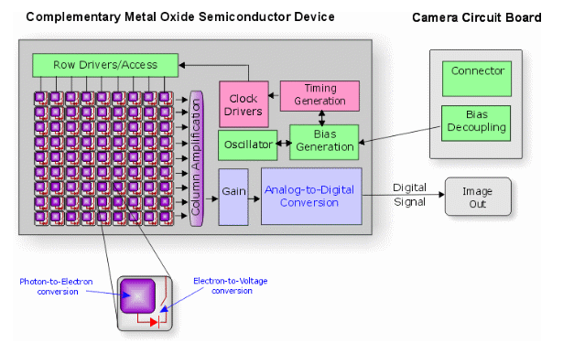
Figure 8. CMOS Functional Diagram.

Although this introduction was quite brief, it does show that digital cameras, even the simple ones found in cell-phones are far more complex than you probably suspected. Their optics are relatively simple, about the same as in a consumer film camera of 50 years ago, but their electronics boost their performance far beyond these early devices. Since optics are expensive and circuitry cheap, the result is impressively cost effective.

Next month I’ll discuss camera control and image capture.

